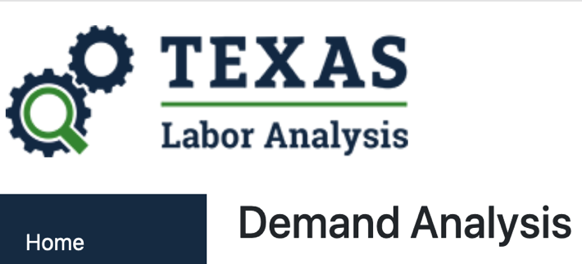 School Counselors

Data is based on 2019-20 labor supply and demands. See https://texaslaboranalysis.com/

Labor Demand Analysis: Education Administers, Kindergarten through Secondary 2019-20
SOC Code | SOC Title | Current Employment (2019) | Education | Entry Level Wage (as of 2019) | Experienced Level Wage (as of 2019) | Employment - Base year 2018 | Employment - Projected year 2028 | Change in employment 2028 - 2018 | Percentage Change | Change in Emp by Growth | Change in Emp by Exits | Change in Emp by Transfers | Total change in Emp | Help Wanted Ads - 3rd Qtr 2020 | Career Cluster
21-1012 | Educational, Guidance, and Career Counselors and Advisors | 25,810 | Master's Degree | $40,776 | $70,310 | 26,292 | 30,050 | 3,758 | 14.29 | 376 | 912 | 1,970 | 3,258 | 2,622 | Education and Training

Gap Analysis Map Report: School Counselors, Kindergarten through Secondary 2019-20
Region Number | Region Name | GAP (Current) = Current Demand (HWOL) - Current Supply (WIT) | GAP (Annual) = Avg. Annual Openings - Annual Graduates
48 | Texas | -622 | 2,150
28 | Gulf Coast | -227 | 510
27 | Middle Rio Grande | -7 | 4
26 | Central Texas | -39 | 55
25 | Texoma | 0 | N/A
24 | Cameron County | -15 | N/A
23 | Lower Rio Grande | -38 | 97
22 | Coastal Bend | -14 | 36
21 | South Texas | -9 | N/A
20 | Alamo | -21 | 156
19 | Golden Crescent | N/A | -26
18 | South East Texas | 6 | N/A
17 | Deep East Texas | -13 | 16
16 | Brazos Valley | 8 | N/A
15 | Rural Capital | -31 | N/A
14 | Capital Area | 29 | 185
13 | Heart of Texas | -1 | N/A
12 | Concho Valley | -6 | -220
11 | Permian Basin | -6 | N/A
10 | Borderplex | -37 | 44
09 | West Central | -15 | 33
08 | East Texas | -26 | N/A
07 | North East | -18 | N/A
06 | Dallas | -26 | 335
05 | Tarrant County | -25 | 203
04 | North Central | -62 | 165
03 | North Texas | -7 | N/A
02 | South Plains | -9 | 33
01 | Panhandle | -8 | 34

