Digital Assessment Tools for Educators

EZAnalyze

http://www.ezanalyze.com/
Provides free, Excel-based tools designed to enhance the data-driven work in which educators engage. EZAnalyze products equip educators, counselors, professionals and students.

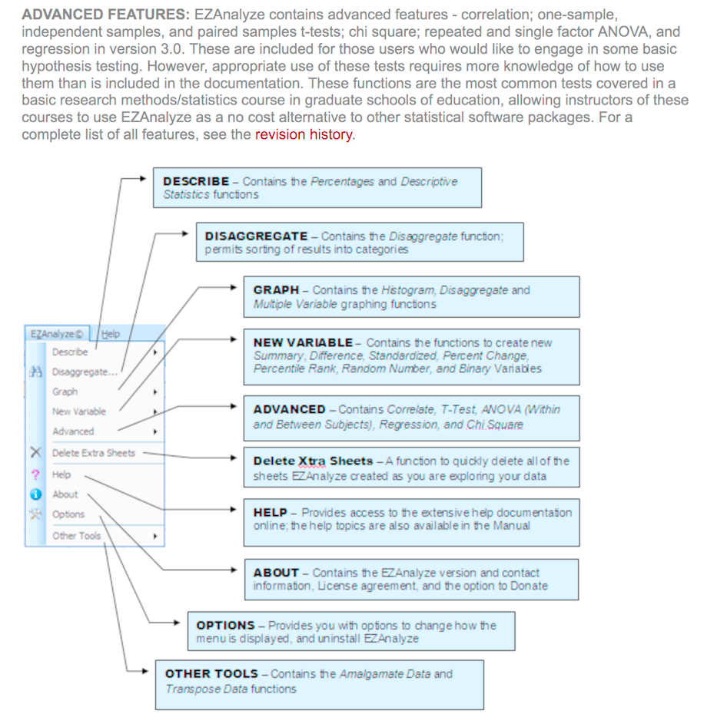

QDA Miner Lite
https://provalisresearch.com/products/qualitative-data-analysis-software/freeware/
A free and easy-to-use computer assisted qualitative analysis software. It can be used for the analysis of textual data such as interview and news transcripts, open-ended responses, etc. as well as for the analysis of still images. It offers basic CAQDAS features such as:
Importation of documents from plain text, RTF, HTML, PDF as well as data stored in Excel, MS Access, etc.
Intuitive coding using codes organized in a tree structure.
Ability to add comments (or memos) to coded segments, cases or the whole project.
Code frequency analysis with bar chart, pie chart and tag clouds.
Coding retrieval with Boolean (and, or, not) and proximity operators (includes, enclosed, near, before, after).
Export tables to XLS, Tab Delimited, CSV formats, and Word format and graphs to PNG, JPEG, formats.

